

Recruitment Pack
2026

Dear Applicant
Thank you for expressing an interest in working for Wellspring Settlement.
We think Wellspring Settlement is a great place to work and we are able to offer a number of benefits including flexible working and a workplace pension scheme. A full list of benefits is included in this pack on page 7.

Wellspring Settlement’s vision is:
Strong dynamic communities where everyone has a good quality life.
- We seek to achieve this vision through the provision of a range of services to the local community including services which aim to improve health and wellbeing and economic resilience.
- We are one of three flagship Family Hubs for Bristol and deliver Children’s Centre services to Barton Hill.
- We run a community hub and provide a range of activities for the community including art and craft, youth activities and one-off events.
- We run a Food Club and have multiple growing opportunities.
- We run BOOST Community, a partnership with Talking Money and Housing Matters, which supports people to build financial confidence and achieve their wider aspirations.
- We celebrate our community and aim to be led by them in our work.

You can find out more about the work of our organisations on our website.
You can learn more about the role and how it contributes to the work of the organisation on page 5.
All of our staff commit to our organisational values (see page 4) and contribute to achieving our organisational vision and strategic priorities (see page 3). You can learn more about our staff team and how you would fit into it on page 6.
We think this is a really exciting opportunity to work within an amazing, vibrant community. If you feel that you could positively contribute to our work, we would very much like to receive an application from you.
Please see Wellspring Settlement’s website for details of the application process and deadline for applications for individual jobs

Yours faithfully
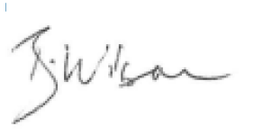
Beth Wilson, Chief Executive Officer of Wellspring Settlement

Wellspring Settlement Priorities and Values

Key Objectives
“We are here for the community and want to be run by the community. Our services should be the ones you want and need.”
These are the opening words of our new Strategic Plan developed in 2023 and 2024 in collaboration with our staff and trustees and most importantly, based on what we heard from the community.
In 2020, Wellspring Settlement was born. The organisation was created from two organisations, both based in Barton Hill, Bristol: Wellspring Healthy Living Centre and Barton Hill Settlement. Both organisations were embedded in the community and wanted the best for the local area and people. The vision of Wellspring Settlement is for strong dynamic communities where everyone has a good quality of life.
For the last four years, we have focused on meeting the needs of the community during the pandemic and then the cost-of-living crisis. Our new Strategic Plan sets out how we want to work with the community and how we are making plans for the future. We have developed 3 aims for the next 3 years which we hope will help us achieve this vision:
Aim 1: We want to deliver services that the community want and need, in a way that makes a difference to people’s lives
We want people to feel welcome and confident and to know that Wellspring Settlement is a place for them, whether or not they need help.
We want to help people to tackle the challenges they face in life and on a day-to-day basis but also to help people think about the future and the long term.
Aim 2: We want to celebrate the community and for the community to be at the heart of the work we do
We want to work with and alongside the local community.
We want to bring the community together and be part of a strong community which supports each other.
Aim 3: We want our buildings and organisation to be sustainable and resilient so that we can continue to be here in the community for many years to come
We want to invest in our volunteers and staff and to provide opportunities for volunteering and work for people from the local area.
We want our buildings to be places that people want to come and spend time in.
There are also four things we are committed to that we think will help us achieve our aims:
#1 Partnerships: we want to work in partnership with other people and organisations where this means we can do more or do things better.
#2 Influence: we want to influence statutory services and decision makers to do things differently and better for our community.
#3 Inclusion: we want everyone to feel welcome and included.
#4 Communication: we want to make sure everyone can find out about what we are doing and opportunities to get involved.

Values:
Wellspring Settlement is a value driven organisation. Our core values are:
- Integrity of word and deed forms the basis of all relationships.
- For us real leadership is serving the community first
- Celebrating diversity; this is our strength
- We will demand equity in all our work
- We will dedicate long-term stamina to achieve our goals
- Nobody is a stranger and everyone feels safe and welcome
- We will do everything we can in partnership.

Role specific information
As a long-standing Deputy CEO leaves our organisation, an exciting opportunity has been created for the organisation to look at ways to expand decision-making and leadership to a wider senior management team. The role of Community & Partnership Development Manager is a new role we’ve created for Wellspring Settlement. This post will be part of the development of this new approach. We think this is an exciting role for someone who has excellent day‑to‑day leadership, planning, coordination, and able to develop Wellspring Settlements’ Community Hub and associated partnerships and services.
Working with our Community Hub and associated projects and partnerships, ensuring high‑quality delivery and a clear, accessible weekly programme of activities.

A bit about us:
- Wellspring Settlement provides a range of services to the local community, working in partnership where possible to grow our offers and bring expertise into our spaces.
- Our model is centred around two hubs focussed on Youth & Family and Community that deliver to their areas of expertise but cross over on partnerships, events and engagement. This model speaks directly to delivering on Wellspring Settlements vision of a thriving, inclusive and socially connected communities prioritising inclusivity, accessibility, and empowerment. The model aligns with best practices in community development and social inclusion delivered in a Trauma informed person-centred way.
- This role is focused on the operational delivery and development of our current community services focused on our:
  - Community Hub offer
  - Home From Hospital Service
  - Gardening for Health Project
  - Horizons Drug & Alcohol Project
  - BOOST Collective Project
  - Community Development & Community Voice

The successful applicant also has the opportunity to work with the broader Wellspring Settlement team to support making our site and services truly welcoming to community members and fit for purpose for services and delivering on cross over engagement, events and development.

This role would suit someone who:
- Has experience managing community services.
- Is confident leading and managing staff teams.
- Understands person‑centred, trauma‑informed, and asset‑based community development approaches.
- Enjoys working in community or mission-driven organisations.
- Has knowledge of partnership working with local organisations, statutory services, and community groups.
- Excellent communication and relationship‑building skill.
- Passion for community empowerment and social justice.

Wellspring Settlement Staff Structure

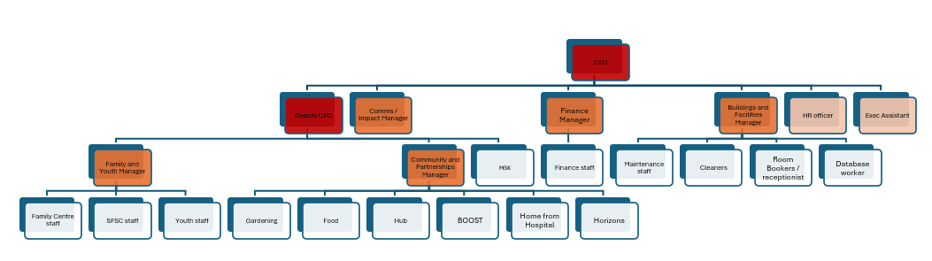
Employee Benefits

- Working for a values-based organisation embedded in a community
- Working in a central location with excellent transport links including cycle routes, trains and buses
- Offices set within community gardens
- Sick pay
- 35 hours full time
- Special leave – paid time off up to 1 week's hours pro rata
- Paid Bank Holidays
- IT equipment (laptops/mobile phones provided)
- Paid training opportunities
- DBS certificate and update service – payments fully reimbursed
- Flexible working arrangements and working from home by agreement
- Social outings
- Annual flu jabs
- Subsidised complementary therapies
- Paid short walk couple of times a week for health and wellbeing
- Support with lifestyle changes (support to stop smoking, reduce alcohol, weight reduction, mental or physical health)
- Pension contributions
- Employee assistance programme as part of our Croner support package
- Out of pocket staff expense reimbursed for work related travel, childcare and food/accommodation whilst on training

