Recruitment Pack
2024

Dear Applicant
Thank you for expressing an interest in working for Wellspring Settlement.
We think Wellspring Settlement is a great place to work and we are able to offer a number of benefits including:
35-hour full time week
flexible working.
workplace pension scheme.
Sage staff benefits
Subsidised wellbeing therapies
Flu jabs
Free parking for staff at our Beam Street site.
Wellspring Settlement’s vision is:
Strong dynamic communities where everyone has a good quality life.
- We seek to achieve this vision through the provision of a range of services to the local community including services which aim to improve health and wellbeing and economic resilience.
- We are one of three flagship Family Hubs for Bristol and deliver Children’s Centre services to Barton Hill.
- We run a community café and provide a range of activities for the community including art, physical activities and one-off events.
- We run a Food Club and have multiple growing opportunities.
- We run BOOST Community, a partnership with Talking Money and Housing Matters, which supports people to build financial confidence and achieve their wider aspirations.
- We celebrate our community and aim to be led by them in our work.

You can find out more about the work of our organisations on our website.
We think this is a really exciting opportunity to work within an amazing, vibrant community. If you feel that you could positively contribute to our work, we would very much like to receive an application from you.
Please see Wellspring Settlement’s website for details of the application process and deadline for applications for individual jobs

Yours faithfully

Beth Wilson, Chief Executive Officer of Wellspring Settlement

Wellspring Settlement Priorities and Values

Key Objectives
We are currently in the process of a full review of our Strategic Objectives. We expect this to be completed later this year/early 2024. We have set interim objectives during this period:

1 | Being a multi-functional organisation, which has a pipeline of new work/funding which meets the needs of our community
2 | All of our work contributes to our 3 impact areas:  - Reducing isolation / building connections  - Creating confidence / opportunities  - Local resource and support
3 | Connecting with our community and building community voice in what we do and what our future priorities are
4 | Building partnerships which are essential to our role as community anchor
5 | Organisational sustainability – focusing on fundraising, finance and people – with a view to being in a place from which growth can happen

Values:
Wellspring Settlement is a value driven organisation. Our core values are:
- Integrity of word and deed forms the basis of all relationships.
- For us real leadership is serving the community first
- Celebrating diversity; this is our strength
- We will demand equity in all our work
- We will dedicate long-term stamina to achieve our goals
- Nobody is a stranger and everyone feels safe and welcome
- We will do everything we can in partnership.

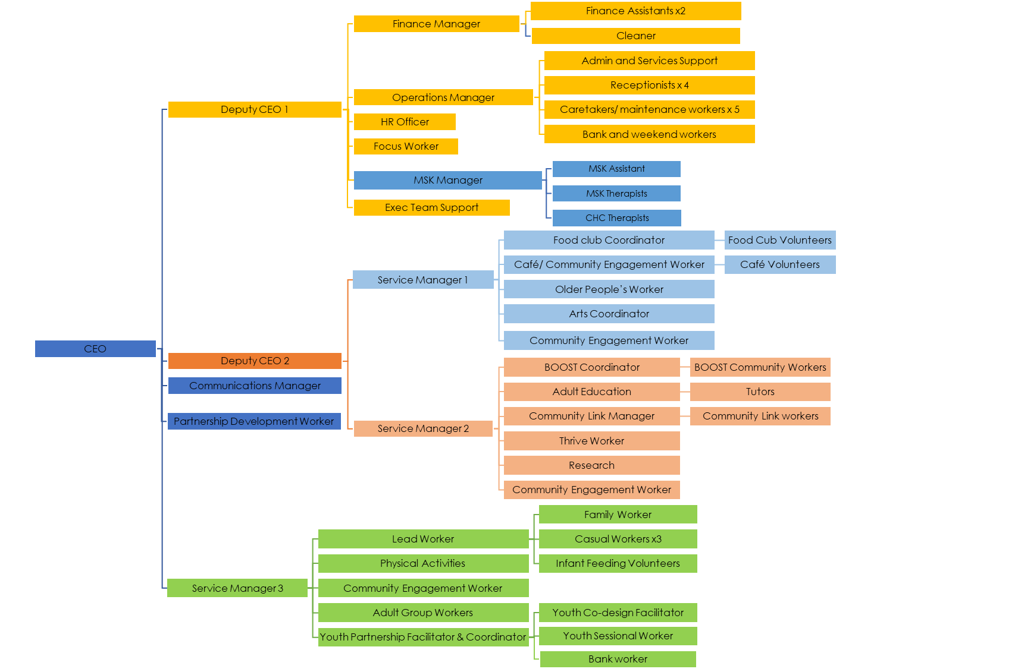
Wellspring Settlement Staff Structure

