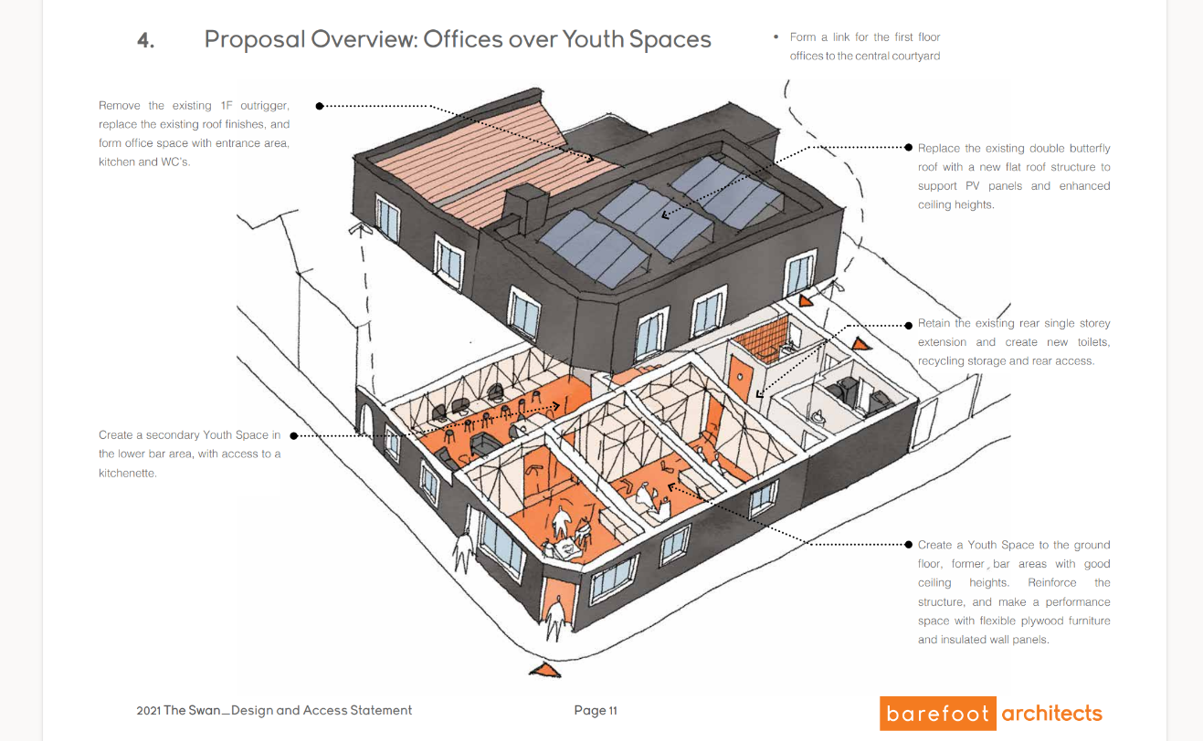

Dear Applicant,

Thank you for your interest in this post. This position is, funded through the National Lottery Community Fund alongside capital investment, as part of the redevelopment of the Swan in Barton Hill which has been bought by Wellspring Settlement.
The Swan was a pub which ceased trading in early 2020. It’s a late 1800s Victorian building, located at the heart of Barton Hill. The site is extremely well positioned for the community and is adjacent to the Wellspring Settlement site. The aim is to develop the building as a community asset, providing space for young people and also for offices upstairs. The building has had some limited structural work to make it safe, but now we are in a position to proceed at pace.
The youth team will work closely together to bring to life our ambition for our work to be:
- Developed in partnership with other local providers so that the centre is a hub of activities for young people;
- Co-produced with young people throughout all stages; and
- Accessible to this diverse community.
We have begun talking with young people, with 3 detached youth work sessions, which will continue until autumn. The youth workers will deliver a range of youth work, up to 3 sessions per week.
If you would like more information, please see the job description and person specification or to visit, please contact Paul Simpson (07889 694848) or Elaine Martin (0117 9556971).
To apply for the post, please complete the application form and email to Sally Jobling at sally.joling@wsb.org.uk. All applicants will be considered and if shortlisted, Interviews arranged. We are applying a rolling deadline which will close once the right candidate has been appointed.

Yours sincerely
Sally Jobling
HR Officer

