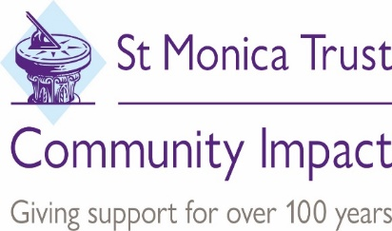

**WELLSPRING SETTLEMENT ARE CURRENTLY LOOKING TO RECRUIT A**

**OLDER PEOPLE - COMMUNITY WORKER**

Wellspring Settlement seeks a dynamic individual to work in inner Central East Bristol on a 3-year project exploring a Community Development approach for older peoples' groups supporting the reengagement of older people with their communities.

You will be enthusiastic, motivated and have experience of working with older people within local communities. To offer support to groups and events which focus on older people’s confidence, wellbeing, community cohesion, digital exclusion, and barriers to engagement with the view to reengaging them with opportunities to take part in, shape, and develop community groups.

This post will be managed by the Wellspring Settlement Hub Manager and will work in partnership with St Monica Trust and other projects that they fund to promote and contribute to the professional running of the project across a wider area.

Those with lived experience as a person from a minority ethnic community and with experience of working with people from BAME communities are encouraged to apply.

This post is funded by the Grateful Society and St Monica Trust Community Impact.

The post is for **24 hours per week**. Th**is is a fixed term contract ending 30th March 2024**

Holiday entitlement is 25 days per annum (pro rata) plus statutory holidays.

**Salary:** Scale E pts 22-25 £21,496-£23,573 per annum pro rata. (Successful candidates start at the bottom of the scale) A job pack including job description and person specification and application form, is available to download from our website search -jobs ([www.wellspringsettlement.org.uk](http://www.bartonhillsettlement.org.uk)).

Please contact Sally Jobling with any enquiries, Email:[**sally.jobling@wsb.org.uk**](mailto:sallyj@bartonhillsettlement.org.uk)Tel:0117 955 6971

**APPLICATION CLOSING DATE: Tuesday 28th June 2022 at 12 noon.**

**INTERVIEW WILL BE HELD ON: Wednesday 6th July 2022**

Wellspring Settlement is committed to safeguarding and promoting the welfare of children, young people and vulnerable adults and expects all staff and volunteers to share this commitment.

Wellspring Settlement is seeking to become an equal opportunities employer that is committed to diversity and inclusion. Applications are encouraged from all members of the community and offers of employment are based on merit and organisational needs.

Wellspring Settlement is a company limited by guarantee registered in England and Wales under number 05031499 and is a charity under number 1103139.